

Topic test 1
Name: __________________________________

Chapter 7: Loans and investments

- Time allowed: 45 minutes
- CAS calculators may be used.
- Part A: 5 multiple-choice questions (5 marks)
- Part B: 9 short-answer questions (27 marks)
- Part C: 3 analysis questions (18 marks)
Part A
Multiple-choice questions
5 multiple-choice questions
1 mark each: 5 marks
Circle the correct answer.
1 Sharon invests $1700 at 6.2% p.a. simple interest, added monthly. How much will she have in 9 months?
A $79.05
B $2648.60
C $1780.70
D $1779.05
E $80.70

[1 mark]
2 Sierra purchases an entertainment system worth $4700 on terms. She paid $900 deposit and 7.2% p.a. flat rate interest on the balance. She pays the balance in equal monthly instalments over 1 year. The amount of each monthly instalment is:
A $316.67
B $339.47
C $391.67
D $414.47
E $419.87

[1 mark]
3 The difference equation tn1 = tn × 1.075 where t1 = 24 000, represents an investment of:
A $24 000 at 7.5% p.a. compounded yearly
B $75 000 at 24% p.a. compounded yearly
C $24 000 at 1.075% p.a. compounded yearly
D $24 000 at 10.75% p.a. compounded yearly
E $1075 at 2.4% p.a. compounded yearly

[1 mark]
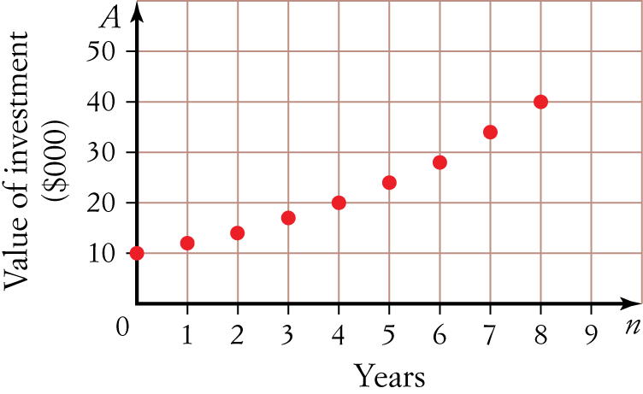
4 The following graph shows the increasing value of an investment over 8 years.
A rule for evaluating the value of the investment, in $ after n years, could be:
A 10 × (1.189)n
B 10 000 × (0.189)n
C 10 × 0.189 × n
D 10 000 × (1.189)n
E 10 000 × 0.189 × n

[1 mark]
5 Neil and Jo each invest $64 000 at the following rates:
- Neil: 8.6% p.a. simple interest.
- Jo: 8.6% p.a. compounding quarterly
At the end of 4 years, Neil will have:
A $3006.40 more than Jo
B $3006.40 less than Jo
C the same amount of money as Jo
D $3932.50 more than Jo
E $3932.50 less than Jo

[1 mark]
Part B
Short-answer questions
9 short-answer questions
27 marks
Show your working where appropriate.
1 Find the interest paid for a week if Arthur borrows $18 000 at 9.2% flat rate of interest.

[2 marks]
2 Renee wants to earn $1000 interest in 2 years. She invests in an account earning 9.8% p.a. simple interest. How much would she need to invest? Answer to the nearest one hundred dollars.

[3 marks]
3 Michael purchases office furniture valued at $3700 on terms of $370 deposit and 52 fortnightly instalments
of $71.56.
a How much interest does he pay in total?

b Calculate the annual flat rate of interest charged. Write your answer as a percentage correct to two
decimal places.

[4 marks]
4 $2700 is invested at 8.9% p.a. compounded yearly.
a Using the formula tn = arn 1, find the rule for the geometric sequence.

b What will be the value of the investment after 5 years?

[3 marks]
5 Bradley invests $8000 in an account paying 7.8% p.a. compounded quarterly.
a Write an expression involving the compound interest formula that can be used to find the value of his investment at the end of 3 years.

b Find the value of his investment at the end of 3 years.

[4 marks]
6 Narelle invests $87 000 in government bonds earning 6.25% p.a. compounding daily. How much interest will she earn in 90 days?

[3 marks]
7 How long will $45 000 need to be invested at 9.1% p.a. compounded 6-monthly in order to earn
$10 000 interest?

[3 marks]
8 Patrice invests her money in an account earning 4.6% p.a. simple interest. She sketches a graph showing the value of her investment over 7 years.
Which of the following could represent her investment? Justify your answer.
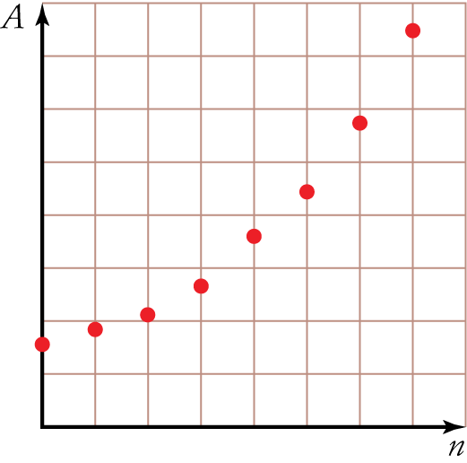
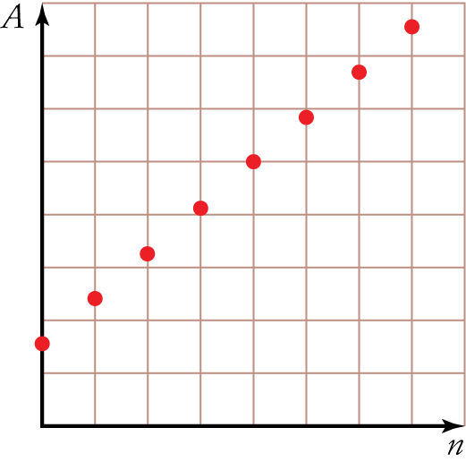
A B

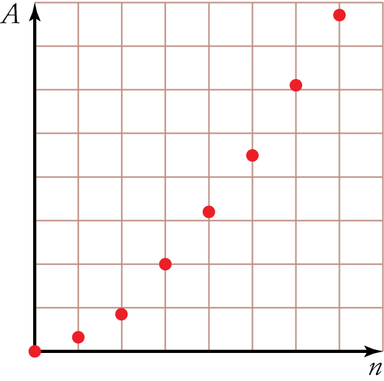
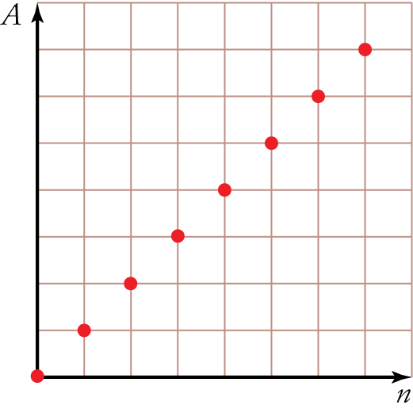
C D

[3 marks]
9 Calculate the effective interest rate for an investment earning 8.2% compounded monthly. Answer as a percentage correct to one decimal place.

[2 marks]
Part C
Analysis questions
3 analysis questions
18 marks
Show your working where appropriate.
1 Melissa invests $16 000 at 6.8% p.a. compounding quarterly. In working out the interest earned in the third year, she writes the following expression where she calculates the interest earned in 3 years and subtracts it from the interest earned in 4 years.
16 000 × 1.0684  16 000 × 1.0683
a Explain why this expression is incorrect.

b Write the correct expression.

c Hence, calculate the interest earned in the third year.

[3 marks]
2 Easy Saver and Super Saver are two investment options at a bank. They both pay interest yearly, but Easy Saver pays simple interest and Super Saver pays compound interest.
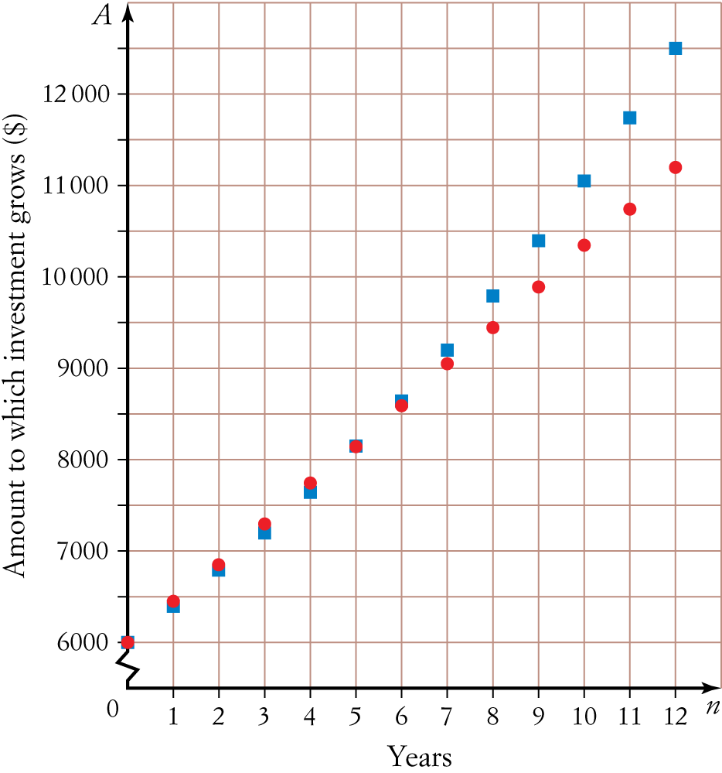
The graph below shows the amount to which each investment has grown over a 12-year period when $6000 was initially invested in both.
a How can you tell that the red-dotted line represents Easy Saver?
b Which investment pays the highest annual interest rate, Easy Saver or Super Saver? Justify your answer.

c After 12 years, the Easy Saver investment has grown to $11 200.
i Find the interest paid yearly.

ii Find the yearly interest rate for the Easy Saver investment. Answer as a percentage correct to one decimal
place.

d After 12 years, the Super Saver investment has grown to $12 500. Find the yearly interest rate for the Super Saver investment. Answer as a percentage correct to one decimal place.

e If someone was deciding between Easy Saver and Super Saver, what advice would you give them? Explain.

[10 marks]
3 Alex was looking to invest money over 7 years. He is comparing different investment accounts:
- Account 1: 8.6% p.a. simple interest.
- Account 2: 8.6% p.a. compounded annually.
a The accounts have the same interest rate per annum but Account 2 earns more interest. Explain why.

Alex was also considering another account:
- Account 3: 8.4% p.a. compounded monthly.
b Calculate the effective interest rate for Accounts 2 and 3.

c Which is the best option for Alex? Explain.

[5 marks]
[ Total marks: 50]

Answers
Part A – Multiple-choice questions [1 mark each]
1 I = ?, P = 1700, r = 6.2, 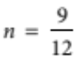
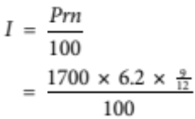
= 79.05
∴ A = I + P
= 79.05 + 1700
= 1779.05
∴ D
2 Balance = 4700  900
= 3800
∴ I = ?, P = 3800, r = 7.2, n = 1
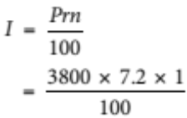
= 273.60
∴ Total to repay = 273.60 + 3800
= 4073.60
∴ Monthly instalment = 4073.60   12
= 339.466…
< 339.47
∴ B
3 t1 = initial value
= the principal
= 24 000
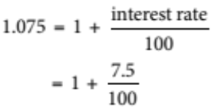
∴ Interest rate = 7.5% p.a.
∴ A
4 Graph is curved, so we are using compound interest.
Therefore, it will take the form:
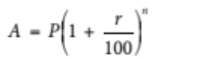 ∴ not options C or E
Reading from the graph, the initial starting value (i.e. the principal) is $10 000
∴ not option A.
Value in parentheses must be 1 ∴ not option B.
∴ D
5 Neil:
I = ?, P = 64 000, r = 8.6, n = 4
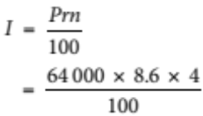
= 22 016
∴ A = I + P
= 22 016 + 64 000
= 86 016
Jo:
N = 4 × 4 = 16
I(%) = 8.6
PV = 64 000
Pmt = 0 ∴ FV = 89 948.496…
FV = ? < 89 948.50
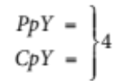
PmtAt = END
∴ Difference = 89 948.50  86 016
= 3932.50
∴ Neil will have $3932.50 less than Jo.
∴ E
Part B – Short-answer questions
1 I = ?, P = 18 000, r = 9.2, 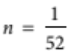 [1 mark]
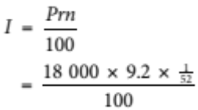
= 31.846…
≈ 31.85 [1 mark]
∴ $31.85 interest paid for a week.
2 I = 1000, P = ?, r = 9.8, n = 2 [1 mark]
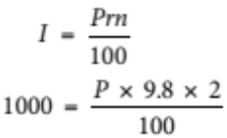 [1 mark]
∴ P = 5102.040…
≈ 5100
Therefore, Renee needs to invest $5100. [1 mark]
3 a Total paid = 74.56 × 52 + 370
= 4091.12 [1 mark]
∴ Interest = 4091.12  3700
= 391.12 [1 mark]
Therefore, he paid $391.12 interest.
b Amount borrowed = 3700  370
= 3330 [1 mark]
∴ I = 391.12, P = 3330, r = ?, n = 2
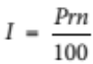
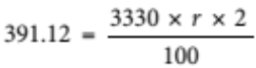
∴ r = 5.872…%
= 5.87%
Therefore, the flat rate of interest charged is 5.87% p.a. [1 mark]
4 a a = principal
= 2700
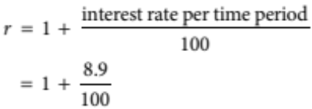
= 1.089
∴ tn = arn-1
= 2700 × 1.089n-1 [1 mark]
b After 5 years, n = 6 [1 mark]
∴ t6 = 2700 × 1.0896-1
= 4135.263…
≈ 4135.26
∴ The value of the investment after 5 years will be $4135.26. [1 mark]
5 a A = ?, P = 8000, r = 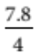 = 1.95% per quarter, n = 3 × 4 = 12 quarters
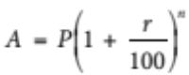 [1 mark for r and 1 mark for n]
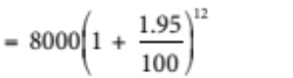 [1 mark]
Should also accept 8000 × 1.019512
b A = 10 086.413…
≈ $10 086.41
His investment will be worth $10 086.41 at the end of 3 years. [1 mark]
6 N = 90 [1 mark for writing known values either in list or in formula.]
I(%) = 6.25
PV = 87 000
Pmt = 0 ∴ FV = 88 351.021…
FV = ? ≈ 88 351.02 [1 mark for FV ]
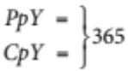 ∴ I = 88 351.02  87 000
PmtAt = END = 1351.02
Therefore, she will earn $1351.02 interest in 90 days. [1 mark]
7 N = ? [1 mark for writing known values either in list or in formula.]
I(%) = 9.1
PV = 45 000
Pmt = 0 ∴ N = 4.50… 6 months [1 mark for N ]
FV = 55 000
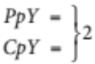 ∴ take 5 lots of 6 months
PmtAt = END
Therefore, it will take 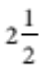 years. [1 mark]
8 Graph B [1 mark]
It is simple interest, so it must be a straightline graph ∴ B or D.
[1 mark for this reason]
We want the value of her investment, so, at n = 0, the value is the principal. Therefore, the graph must start above the zero on the y-axis ∴ B.
[1 mark for this reason]
9 I = 8.2% = 0.082, n = 12
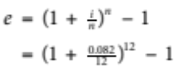 [1 mark]
= 0.0851…
≈ 8.5% [1 mark]
Therefore, the effective interest rate is 8.5%.
Part C – Analysis questions
1 a It has the interest rate and years as compounding yearly, but it should be compounding quarterly.
[1 mark]
b 16 000 × 1.01716  16 000 × 1.01712 [1 mark]
c 1366.277… ≈ 1366.28
Therefore, the interest earned in the third year is $1366.28. [1 mark]
2 a It is a straight line which represents a simple interest investment. [1 mark]
b Easy Saver [1 mark]
Initially, Easy Saver earns the most interest. This can be seen by the fact that the red-dotted line is initially above the line marked with squares. [1 mark]
c i Total interest = 11 200  6000
= 5200 [1 mark]
∴ Interest per year = 5200   12
= 433.333…
≈ 433.33
∴ Interest paid per year is $433.33. [1 mark]
ii I = 433.33, P = 6000, r = ?, n = 1 [1 mark for using correct I and P ]
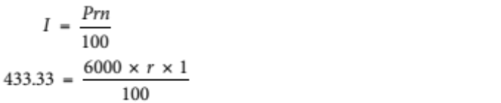
∴ r = 7.22…% p.a.
≈ 7.2% p.a. [1 mark]
d N = 12 [1 mark for writing known values either in list or in formula.]
I(%) = ?
PV = -6000
Pmt = 0 ∴ r = 6.30…
FV = 12 500 ≈ 6.3% p.a.
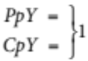
PmtAt = END
Therefore, the interest rate for the Super Saver investment is 6.3% p.a. [1 mark]
e If investing for more than 5 years, the Super Saver account is the best option. Otherwise, Easy Saver
is the best option. This can be seen on the graph as below 5 years the Easy Saver graph is above the Super Saver but from 5 years it is reversed. [1 mark]
3 a The interest earned in Account 2 is compounded, which means the interest earned each year gets added to the principal. Thus, interest is earned on the previous year’s interest as well as on the principal. In contrast, Account 1 earns simple interest, which means interest is earned on the principal only.
[1 mark]
b Account 2: e = 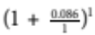  1 = 0.086
= 8.6% [1 mark]
Account 3: e = 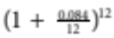  1 = 0.08731…
≈ 8.73% [1 mark]
c Account 3 is the best option. [1 mark]
It has the higher effective interest rate and will therefore pay higher interest over time. [1 mark]

